**P26. Consider transferring an enormous file of L bytes from Host A to Host B. Assume an MSS of 536 bytes.**

**a. What is the maximum value of L such that TCP sequence numbers are not exhausted? Recall that the TCP sequence number field has 4 bytes.**

**b. For the L you obtain in (a), find how long it takes to transmit the file. Assume that a total of 66 bytes of transport, network, and data-link header are added to each segment before the resulting packet is sent out over a 155 Mbps link. Ignore flow control and congestion control so A can pump out the segments back-to-back and continuously.**

a) There are 2^32 = 4,294,967,296 possible sequence numbers.

The sequence number does not increment by one with each segment. Rather, it increments by the number of bytes of data sent. So the size of the MSS is irrelevant -- the maximum size file that can be sent from A to B is simply the number of bytes representable by 2^32 ≈ 4 Gbytes.

b) segments data = 2^32 / 536 = 8,012,999

header size = 66 bytes

total header = 8,012,999 * 66 bytes = 528,857,934 bytes

total transmitted = 2^32 + 528,857,934 bytes = 4.824 * 10^9 bytes

transmit time = 4.824 * 10^9 * 8 bits / 155 Mbps = 249 seconds

**P27. Host A and B are communicating over a TCP connection, and Host B has already received from A all bytes up through byte 126. Suppose Host A then sends two segments to Host B back-to-back. The first and second segments contain 80 and 40 bytes of data, respectively. In the first segment, the sequence number is 127, the source port number is 302, and the destination port number is 80. Host B sends an acknowledgment whenever it receives a segment from Host A.**

**a. In the second segment sent from Host A to B, what are the sequence number, source port number, and destination port number?**

**b. If the first segment arrives before the second segment, in the acknowledgment of the first arriving segment, what is the acknowledgment number, the source port number, and the destination port number?**

**c. If the second segment arrives before the first segment, in the acknowledgment of the first arriving segment, what is the acknowledgment number?**

**d. Suppose the two segments sent by A arrive in order at B. The first acknowledgment is lost and the second acknowledgment arrives after the first timeout interval. Draw a timing diagram, showing these segments and all other segments and acknowledgments sent. (Assume there is no additional packet loss.) For each segment in your figure, provide the sequence number and the number of bytes of data; for each acknowledgment that you add, provide the acknowledgment number.**

* Host A and B are communicating over a TCP connection, and Host B has already received from A all bytes up through byte 126.
* The first and second segments contain 80 and 40 bytes of data, respectively.
* The first segment of sequence number is 127.
* The source port number is 302.
* The destination port number is 80

a) Sequence number = first segment of sequence number+ destination port number =127+ 80 = 207

Source port number = 302

Destination port number= 80

b) Acknowledgement number= 207

Source port number = 80

Destination port number= 302

c) Acknowledgement number=127

e) 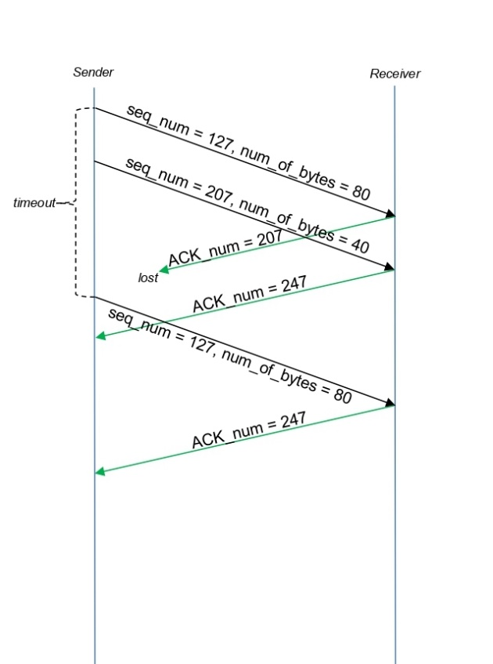

**P28. Host A and B are directly connected with a 100 Mbps link. There is one TCP connection between the two hosts, and Host A is sending to Host B an enormous file over this connection. Host A can send its application data into its TCP socket at a rate as high as 120 Mbps but Host B can read out of its TCP receive buffer at a maximum rate of 50 Mbps. Describe the effect of TCP flow control.**

• As given that the link capacity is only 100 Mbps, so the sending rate of Host A can be almost 100 Mbps.

• Host A sends data into the TCP receive buffer at a rate as high as 120 Mbps.

• The receive buffer fills up at a rate of about 50Mbps.

• Host B removes data from the TCP receive buffer at a rate of 50 Mbps.

• When the TCP receive buffer is full, Host B sets the RcvWindow to 0. It is a signal to Host A to stop sending data.

• Host A stops sending the data into TCP receive buffer and waits till it receives a TCP segment with RcvWindow > 0.

• Host A will stop and start sending data depending on the value of the RcvWindow that Host A receives from Host B.

• Thus it can be determined that the on an average, the long-term rate at which Host A sends data to Host B can be no more than 50Mbps.

**P29. SYN cookies were discussed in Section 3.5.6.**

**a. Why is it necessary for the server to use a special initial sequence number in the SYNACK?**

**b. Suppose an attacker knows that a target host uses SYN cookies. Can the attacker create half-open or fully open connections by simply sending an ACK packet to the target? Why or why not?**

**c. Suppose an attacker collects a large amount of initial sequence numbers sent by the server. Can the attacker cause the server to create many fully open connections by sending ACKs with those initial sequence numbers? Why?**

a) The server uses special initial sequence number (that is obtained from the hash of source and destination IPs and ports) in order to defend itself against SYN FLOOD attack.

b) No, the attacker cannot create half-open or fully open connections by simply sending and ACK packet to the target. Half-open connections are not possible since a server using SYN cookies does not maintain connection variables and buffers for any connection before full connections are established. For establishing fully open connections, an attacker should know the special initial sequence number corresponding to the (spoofed) source IP address from the attacker. This sequence number requires the "secret" number that each server uses. Since the attacker does not know this secret number, she cannot guess the initial sequence number.

c) No, the sever can simply add in a time stamp in computing those initial sequence numbers and choose a time to live value for those sequence numbers, and discard expired initial sequence numbers even if the attacker replays them.